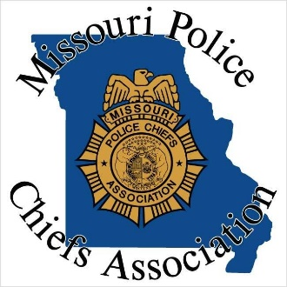

1001 East High Street – Jefferson City, MO 65101 – (573) 636-5444 Phone (573) 636-6634 Fax

Email: jhudson@mopca.com

Training Opportunity

We are opening the training listed below. These courses will be held during the year end conference. IF YOU ARE REGISTERING FOR THE YEAR END CONFERENCE THESE CLASSES ARE INCLUDED IN YOUR REGISTRATION.

High Achiever Leadership

Instructor: Gary Wilbers
December 9, 2019; 8:00 a.m. – 5:00 p.m.
(Lunch Included)
8 CEH’s - $100
(3 Hrs. Technical, 4 Hrs. Interpersonal, 1 Hr. Legal)

Understanding Legal Marijuana for Chiefs

Instructor: Chris Halsor
December 10, 2019; 1:00 p.m. – 5:00 p.m.
4 CEH’s - $60
(2 Hrs. Technical, 2 Hrs. Legal)

Chief to Chief

Instructor: Edward Roessler
December 11, 2019; 8:00 a.m. – 11:00 a.m.
3 CEH’s - $60
(3 Hrs. Interpersonal)

TRAINING LOCATION:
Capitol Plaza Hotel
415 West McCarty, Jefferson City, Missouri 65101

PARTICIPANT APPLICATION
* * *

Please check mark all the courses you will be attending:

High Achiever Leadership, December 9, 2019 - $100
Understanding Legal Marijuana for Chiefs, December 10, 2019 - $60
Chief to Chief, December 11, 2019 - $60

(The fee will cover breaks, training materials, and CEHS.)

Name: POST #:
Agency:
Address:
City:State: Zip Code:
Agency Phone: E-Mail:
**A 3% surcharge will be added for credit card processing**
Bill Me: Payment Included:
Credit Card # Expiration Date:
CVS (Back of Card:
If you want to be billed please provide billing contact, billing address, and email.

Billing Contact: Billing Address:

Billing Email:

Return this Registration to:

Missouri Police Chiefs Association
1001 East High Street
Jefferson City, MO 65101
FAX (573) 636-6634
jhudson@mopca.com

