We would like to support the efforts of the Missouri Police Chiefs Charitable Foundation in our community.

Sponsor Level:
Platinum $5,000 +
Gold $2,500 - $4,999
Silver $1,000 - $2,499 Bronze $100 - $999
$
If you have any questions, contact the MPCCF Director, Sheldon Lineback at 573.633.5444 or slineback@mopca.com

Mail this form along with your check to:
MPCCF • 1001 East High Street • Jefferson City, Missouri 65101

Contributions are tax-deductible
Company: Address:

City: State Zip Code:

Telephone: Website: Contact: Title: Email:

Like Winning in Sports,
It Takes Teamwork to Ensure a Safer Missouri.
So Please Join the Missouri Business
& Law Enforcement Team!
1001 East High Street Jefferson City, Missouri 65101
Ph: 573.636.5444 Fax: 573.636.6634
www.mopca.com

Missouri Police Chiefs Partnership Program for a
SAFER MISSOURI

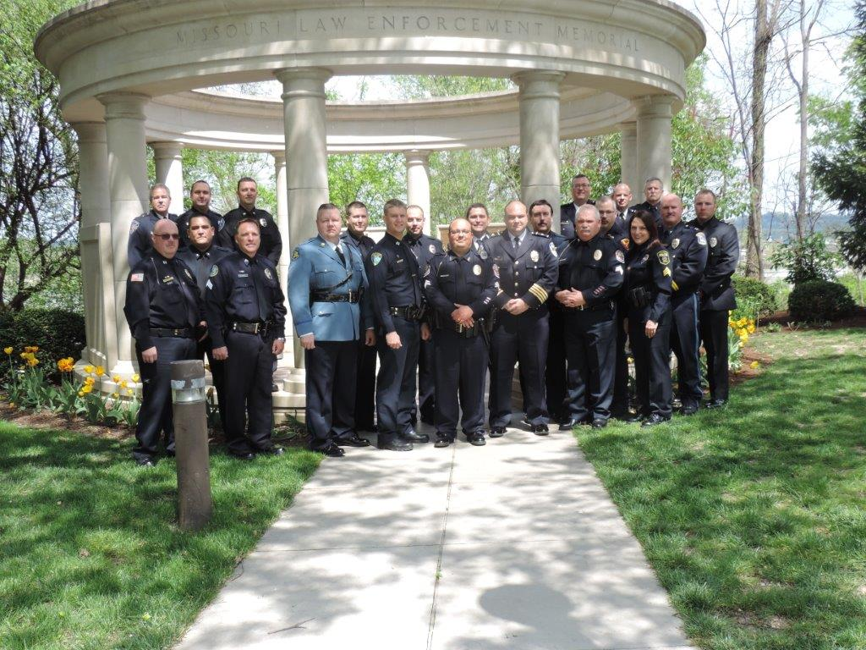

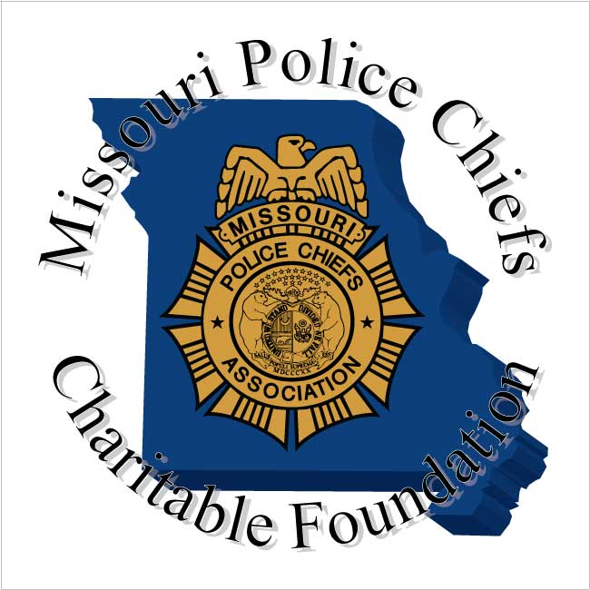

Who We Are
The Missouri Police Chiefs Charitable Foundation (MPCCF) is a not-for-profit 501c3 corporation formed in 1996 to provide assistance and service to citizens and law enforcement.

Our Mission
Our mission is two-fold: To promote the safety of Missouri’s youth through education programs and to advance the quality and professionalism of law enforcement by supporting higher standards and offering advanced officer training.

The Missouri Police Chiefs is dedicated to its mission and committed through its efforts to enhance public safety and services directly to and working with local law enforcement enabling the delivery of community services and programs.

The Missouri Police Chiefs embraces and promotes partnerships that foster communication, enhanced services, utilization of technology, and provides enhanced understanding and educational opportunities.

We look forward to working with our sponsors and partners in achieving our goals and commitment to our mission. We know working together provides limitless opportunities and relationship that will strengthen Missouri communities and Missouri law enforcement.

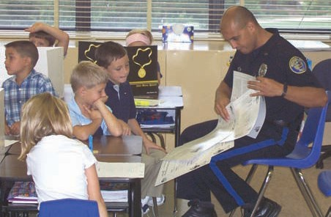

What We Do

- Serve as the State D.A.R.E. Training Center for the State of Missouri.
- Provide approximately 30,000 D.A.R.E. work books to children across the state of Missouri.
- LE Agency certification program. This program requires LE agencies to meet professional standards and policies. Agencies are required to be audited to ensure that they are following these standards and provide proofs of compliance with professional law enforcement standards of operation.
- The MPCCF is recognized and licensed by the State of Missouri as an approved provider of law enforcement continuing education.
- MPCCF works to and has successfully provided new equipment and technology to law enforcement agencies across the state of Missouri.
- MPCCF has partner with Lincoln University to create the only Missouri –based Command College which candidates can also earn a Master’s Degree.
- Annually provides School Resource officer certification training that is designed to provide training and prepares LE officers to be productive and effective in Missouri Schools.
- Annually provides education scholarships for Missouri’s youth seeking to further their education.

Team Work
The MPCCF believes in teamwork and a coopera- tive effort between Missouri businesses, citizens and law enforcement. With your support, we can continue to provide the training and services that benefit young people and improve law enforce- ment standards throughout the state.

Sponsors
- Will be identified and linked on the MPCCF website and identified in the monthly newsletter.
- Platinum, Gold and Silver Sponsors will also receive a wall plaque.
- Platinum and Gold Sponsors will be displayed on MPCCF Conference/Events.
- Will be recognized at Conference Events.
- Platinum, Gold and Silver Sponsors will have the opportunity to present at one of the 10 monthly board meetings throughout the year.
- Platinum members will have the opportunity to present at one of the two annual conferences.

  - .

